On Sickle Cell Society Letterhead

Dear

Support Sickle Cell Society by taking part in our 2016 Superhero Run!

Thank you for requesting a Do it for Charity Superhero Run information pack.
We can’t wait for you to join us in becoming a real-life superhero and supporting Sickle Cell Society on the 15th May!

This information pack provides you with everything you need in order to take part, including location, date of the event, where you can head to for vital fitness, kit and fundraising advice and, most importantly, how you can get involved!

Free costumes, for both male and female runners, will be provided on the day. Don’t forget to grab yours and decide which hero you want to turn into, alternatively you can bring your own costume – all superheroes are welcome!

We have thousands of runners expected to take part whilst raising funds for extraordinary charities across the country, so claim your place today, pull on your cape and join us on the nationwide Do it for Charity 5km or 10km run series!

Kind regards



Clare Spight
Do it for Charity Run Coordinator

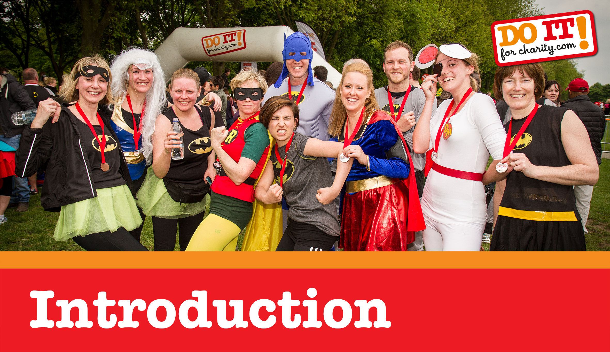

Thousands of heroes will descend upon Regent’s Park in May in a bid to raise funds for their chosen charity in the Do it for Charity Superhero Run. Now is your chance to join them!

Whether you run, jog or walk – this event is all about the taking part, not the winning. No previous experience is required and with a bit of training, the 5km or 10km distance should easily be within your capabilities! Plus, with our training and fitness advice we expect you will be cape-ready in no time!

All you need to do is pledge to raise £100 for Sickle Cell Society and reserve your place by completing the enclosed registration form. Alternatively you can register online at www.doitforcharity.com.
Sickle Cell Society is counting on your support!

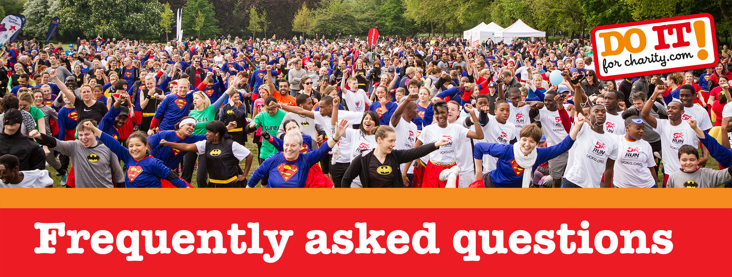

When and where
The 2016 Do it for Charity Superhero Run will take place on Sunday 15th May in London’s Regent’s Park. This parkland venue offers a perfect setting for you to enjoy your run on behalf of Sickle Cell Society! Costume collection will be from 9:45am with the run due to start from approximately 11:00am.

How fit do I need to be?
Hundreds of thousands of people take part in 5km and 10km runs every year - many of them for the first time. It's therefore perfectly achievable for the 'average' person to take part in this event but in order to maximise your enjoyment we do recommend you do some training! Help is also on hand in the form of the www.doitforcharity.com fitness pages where we give you a sample training plan – Sickle Cell Society will also be able to give you help and support.

What kit will I need?
Running is one of those great sports where you won't need lots of expensive equipment. A good pair of running shoes should last for around 500 miles which is 8 months on an average 15 miles/week training schedule. Once again help is at hand in the form of www.doitforcharity.com kit pages where you will learn the importance of choosing the correct shoes. Please note however that it’s important that you buy them at least a couple of months before the event itself so that have a chance to wear them in!

Both male and female Do it for Charity Superhero costumes will be provided for you on the day free of charge, so don’t forget to pick one up! Alternatively you are more than welcome to bring your own costume – all superheroes are welcome!
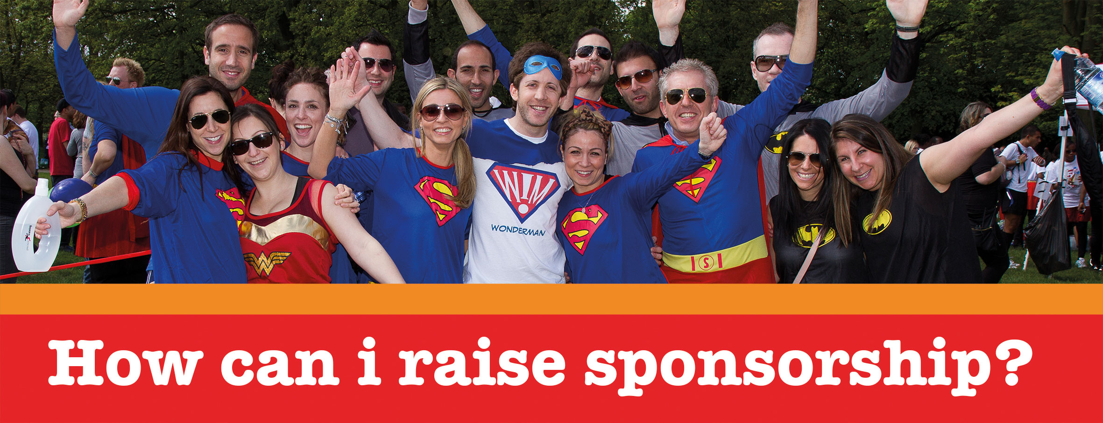

Most charities will ask you to raise a minimum of £100 if you are taking part in the Do it for Charity 5km or 10km run. As you know, these funds are incredibly valuable to Sickle Cell Society and we are here to support your goal of achieving your target!

Top fundraising tips include asking your employer to match everything you raise pound for pound. You could also ask people to sponsor you per kilometer (so the minimum you'll get from anybody is £5 which means you only need to find 20 people to reach the £100 fundraising target!)

You can create your own personal fundraising page on www.doitforcharity.com/give where people can simply donate online.

Once again more advice is available is on www.doitforcharity.com on the fundraising advice pages and Sickle Cell Society should be able to help out as well.

What do I need to do next?
Simply complete the enclosed registration form or register online at www.doitforcharity.com. As long as you commit to raising the minimum sponsorship Sickle Cell Society will be delighted to have you running on their behalf!

RESERVE YOUR PLACE TODAY!

Registration Form
Please complete this form and return it to the address below as soon as possible – places are extremely limited so it’s important that you book early to avoid disappointment! Please also provide your £25 registration fee cheque (payable to ‘Skyline’) or credit card details (see below).

Do it for Charity Superhero Run Sunday 15th May 2016
5km Run | 10km Run

How did you find out about this event? ____________________________________________________

First Name _______________________________ Surname ___________________________________

Address_____________________________________________________________________________

________________________________________________________ Post Code___________________

Email Address _____________________________________ Organisation ________________________

Tel No. (Day)_________________________________ Tel No. (Other)____________________________
(Please specify as this will be our primary source of contact)

Male/Female ____________ | Date of Birth _____________________

I enclose a cheque payable to ‘Skyline’
Please charge my Visa / Mastercard / Delta / Switch with the £25 fee as follows:

Card Number |  |  |  |  |  |  |  |  |  |  |  |  |  |  |  |  |  |  |  |  | Valid From |  | Expiry Date | Issue No  (switch)
 |  |  |  |  |  |  |  |  |  |  |  |  |  |  |  |  |  |  |  |  |  | ____ / ____ | ____ / ____ _____________ | ____

IMPORTANT: I confirm that I have read the Booking Terms & Conditions, Medical Restrictions and Important Notice overleaf (if these are not listed overleaf please call 0207 424 5533 to request a copy) and I understand and agree to be bound to those terms and conditions and to comply fully with the same.
Please note - the Booking Terms & Conditions, Medical Restrictions and Important Notice overleaf need to either be printed on the reverse of this sheet, or attached securely to this form.

Signature __________________________________________ Date _____________________________

Tick here if you do not wish to receive details of other offers from either the charity or other organisations
Please complete this form and return it to: c/o Do it for Charity, 31 Corsica Street, London N5 1JT

For office use only  Cheque Name____________________  SCS 22RUN  DIFC LON 15RUN | Cheque Number _________________

Please read all sections of this page carefully before signing the declaration below

Booking Terms and Conditions
- By paying the registration fee you are registering your place on a doitforcharity.com 5km or 10km event for your chosen charity and undertaking to raise the £100 minimum sponsorship for such charity
- All registrations fees are non-refundable. However you can transfer your place to another runner at any time up to a week before the event by calling us on 0207 424 5533
- The minimum age for participants is 8, and under 16's will need to ensure that they run with a responsible adult that is named by the parent / guardian. Those under 18 will need a letter of parental consent.
- Precise dates and venues were correct at time of going to press but are subject to change
- Photography and filming may take place at this event to be used for promotional material. Please inform Skyline or a member of staff on the day of the event if you do not wish to feature

Medical Restrictions
You should be reasonably fit to take part in this event and you are strongly advised to undertake some training. If you have any doubts about your ability to take part including without limitation having pre-existing medical conditions you should contact your doctor to seek advice.
By participating in this event you give full permission for any medical details that may collected by the medical provider(s) to be shared with Skyline Events.

Important Notice
Running is an active sport and participation in such sports necessarily involves a risk of injury or death regardless of the standard of the organisation of the event you are taking part in. I voluntarily accept all the risks inherent in this event and I agree for myself and my personal representatives to indemnify and hold harmless Skyline Promotions Ltd against any claim or claims whether on my own account or from third parties arising out of any accident or incident resulting in any loss or damage (including bodily injury and death).

I confirm I have read all the above sections marked Booking Terms and Conditions, Medical Restrictions and Important Notice, and I understand and agree to be bound to those terms and conditions and to comply fully with the same.

Name ______________________ | Signature ________________ | Date _________

