 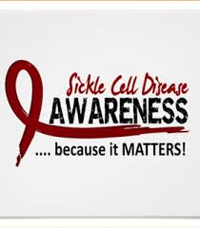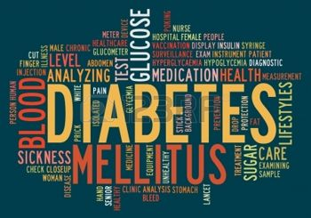

**WFMHP BBQ**

**Come along and enjoy short talks on both diabetes & sickle cell. Take part in fun health quizzes. Make delicious healthy smoothies or**

**Just enjoy the delicious Caribbean inspired BBQ & entertainment**

**Information on: volunteering or fundraising activities for both charities or just get up to date info on up and coming events for both**

**SO COME ALONG ON**

**FRIDAY 17THJUNE 2-6pm**

**GREG CLOSE**

**28 GREG CLOSE**

**LEYTON**

**LONDON E10 6SJ**

Please forward the names of those attending to Francesca Bailey at [francesca.bailey@east-thames.co.uk](mailto:francesca.bailey@east-thames.co.uk) or call 020 8522 – 2367 or Sophie Spilsbury on 020 8522 - 2340