The Sickle Cell Society

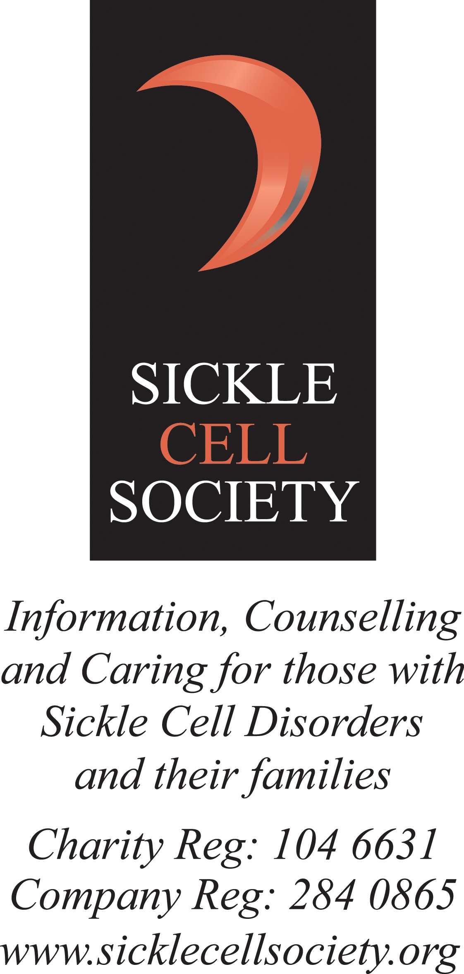Volunteer & Community Lead - Job Description

Job Title: Volunteer Co-ordinator

Hours: 21 hours per week
Salary: £16,200 pro-rata (plus NI & Pension)

Contract: Two-year fixed term appointment (with potential to extend)

Line Managed by: Fundraising Manager

Responsible for: Volunteer recruitment, co-ordination, support and development

Location: Remote working (One day minimum at 54 Station Road)

Job Purpose: Community Volunteers are vital to the work of the Sickle Cell Society. They help us in many ways such as increasing awareness and understanding of sickle cell, involving local people with the work of the Society and raising much needed funds to help us improve the lives of individuals with sickle cell and their families.

The role of the Volunteer Coordinator is to take responsibility and leadership in developing our existing volunteers and recruiting/growing the number of volunteers at the Society. Essential is your ability to deploy them into tasks/roles suitable to their individual skills; to enable them to have a positive experience in supporting the work of the Society.

Main areas of focus volunteers are required for include;
- Service-user/Members events e.g. Annual General Meeting, face to face and/or online workshops and project activities/events, children’s activities;
- Supporting the Helpline team to have advice stands at national events e.g. British Society of Haematologists, ASCAT (Annual Scientific Conference on Sickle Cell and Thalassaemia), universities’ and Black History Month events and activities;
- Annual Children’s holiday – a 2-3 day event during the summer;
- Community outreach to support awareness raising / engagement;
- HQ office support;
- Social media activity;
- Fundraising e.g. supporting regional and national community fundraising;
- Co-ordinating volunteers to support the successful development of local SCD support groups.
The role will be supported by the Fundraising Manager and work closely across all our staff teams.

About the Sickle Cell Society (SCS)
The Sickle Cell Society (SCS) is the only national charity in the UK that supports and represents people affected by a sickle cell disorder. We provide information, advice and support to enable people to improve their overall quality of life. Approximately 15,000 people in the UK have a sickle cell disorder. These inherited conditions predominantly affect people of Black African and Black Caribbean heritage; and to a lesser extent people of Mediterranean, Middle Eastern, South Asian and Central/South American heritage. This inherited blood condition causes the collapse (sickling) of red blood cells, reducing their capacity to carry oxygen around the body. This causes acute anaemia and extreme pain as cells cannot pass freely around the body. Regular blood transfusions are often required to keep people well. A high proportion of our client group also suffer disability relating to stroke, or damage to vital organs which can lead to organ failure. We assist and enable people living with SCD to realise their full potential whilst successfully managing the challenges they face in living with this potentially life-limiting condition.

We are a small, friendly and closely knit team of 12 skilled and highly committed staff (3 full time and 9 part time) and over 30 active volunteers. A vital resource; our aim is to invest in the passion, commitment and support of our volunteers and their development. We rely on their support to increase our capacity. We draw on their knowledge and experience to inform the development of our service-users’ activities and effectively utilise volunteers’ life-skills to support a wide range of tasks, activity and events.

Key Responsibilities

- To set up a Volunteer Steering Group;
- To lead on the recruitment process for volunteers; motivating people with relevant skills to support the SCS in its work activities, including interviewing and assigning volunteers for particular roles suited to their skills set;
- Network and attend meetings and events to attract new volunteers;
- To ensure SCS Safeguarding policy and processes are adhered to with regards to recruitment and training of volunteers; including processing of CRB and other checks;
- To show leadership by developing, motivating and monitoring volunteers in their work and to enable them to do their best and reach their full potential;
- To ensure volunteers are appropriately deployed to the activities that best match their interests and skill-set;
- To maintain records (data base and excel spreadsheet work) of all work undertaken by volunteers;
- To develop and regularly update a volunteer manual
- To document tasks regularly performed by volunteers to ensure business continuity and facilitate training.
- To overhaul the current SCS volunteer system including;
  - Improvement of processes for recruiting new volunteers;
  - Design/implementation of a reward scheme to support volunteer development;
- To brief volunteers on their roles and ensure they have relevant and up to date information to support their role/s;
- To liaise regularly with volunteers, support their on-going engagement and motivation, e.g. volunteer web-page or digital newsletter; and to organise an annual celebration event for SCS volunteers;
- To work closely with fundraising and service delivery teams to ensure the Society’s volunteer needs are met;
- Monitor and evaluate the success of the Volunteer Programme to demonstrate the value and impact of SCS volunteers and also to monitor individual skills development for volunteers.
- To support any other tasks relevant to the support of the volunteer programme as required by the Fundraising Manager.

The Sickle Cell Society

Volunteer Co-ordinator - Person Specification

Essential | Desirable
Qualifications  - A ‘Level or demonstratable experience in a similar role. | - Degree level qualification;  - Experience of working within a health / social care charity.
Experience  Minimum two years’ experience of volunteer recruitment and development. | - Demonstratable understanding of developing a Volunteer Programme from inception to delivery; including all legal requirements and policies
Knowledge and Skills  - Excellent interpersonal and communication skills;  - Ability to plan, prioritise and manage conflicting deadlines;  - Excellent IT skills inc MS Office;  - Excellent organisational skills and attention to detail. | - Understanding of Sickle Cell Disease;  - Strong networking skills;  - Experience of budgeting.  - Experience of managing recruitment processes;  - Experience of supervision  - Experience of training provision
Personal Qualities
- Innovative and creative, able to identify and act upon new opportunities;
- An excellent communicator with an ability to promote/build awareness of SCS to develop strong relationships;
- Self-motivated and able to work innovatively in a busy working environment;
- Passion and knowledge in all aspects of The Society’s work and/or willingness to learn.

Personal Circumstances
- Flexibility to occasionally attend events outside of normal working hours including evenings and weekends (face-to-face or remotely).

BOTH THE JOB DESCRIPTION AND THE PERSON SPECIFICATION ARE SUBJECT TO THE CHARITY’S EQUAL OPPORTUNITIES POLICY.

